Working with service account -

**ACCESS CLOUD STORAGE BUCKET FROM VM USING SERVICE ACCOUNT**

GO TO IAM

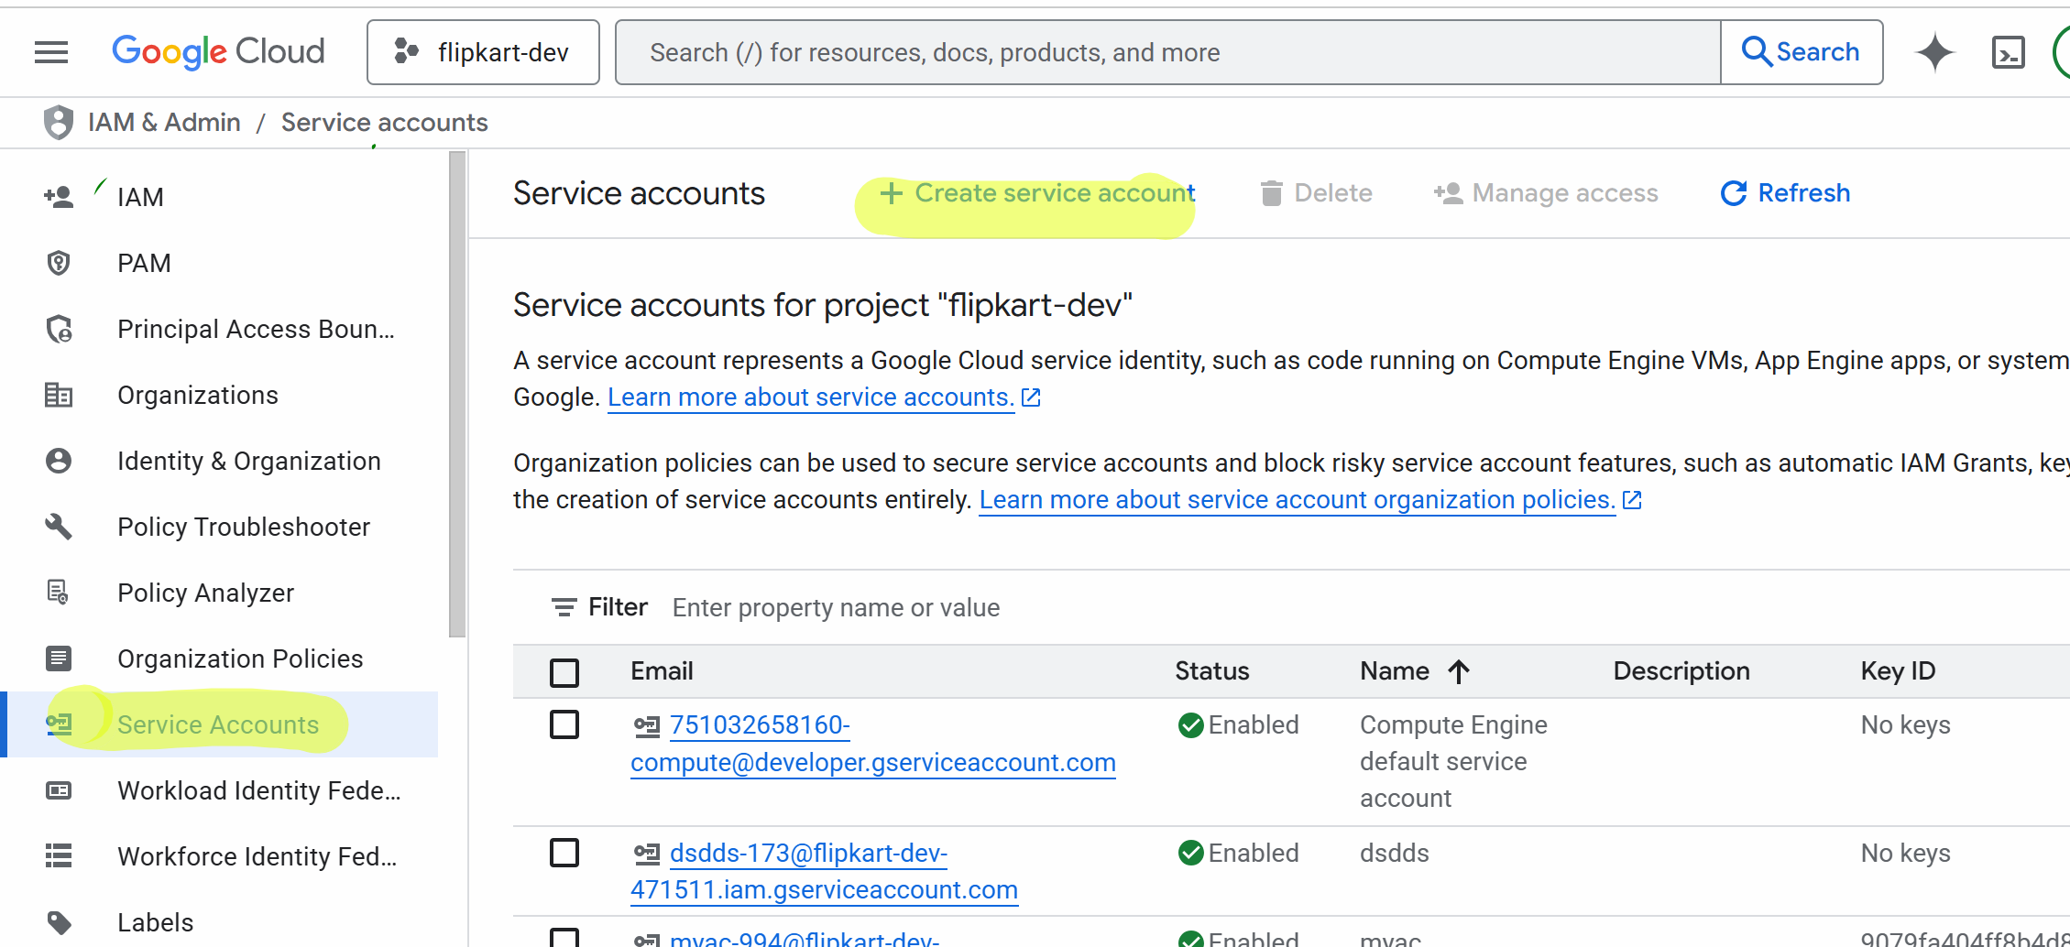

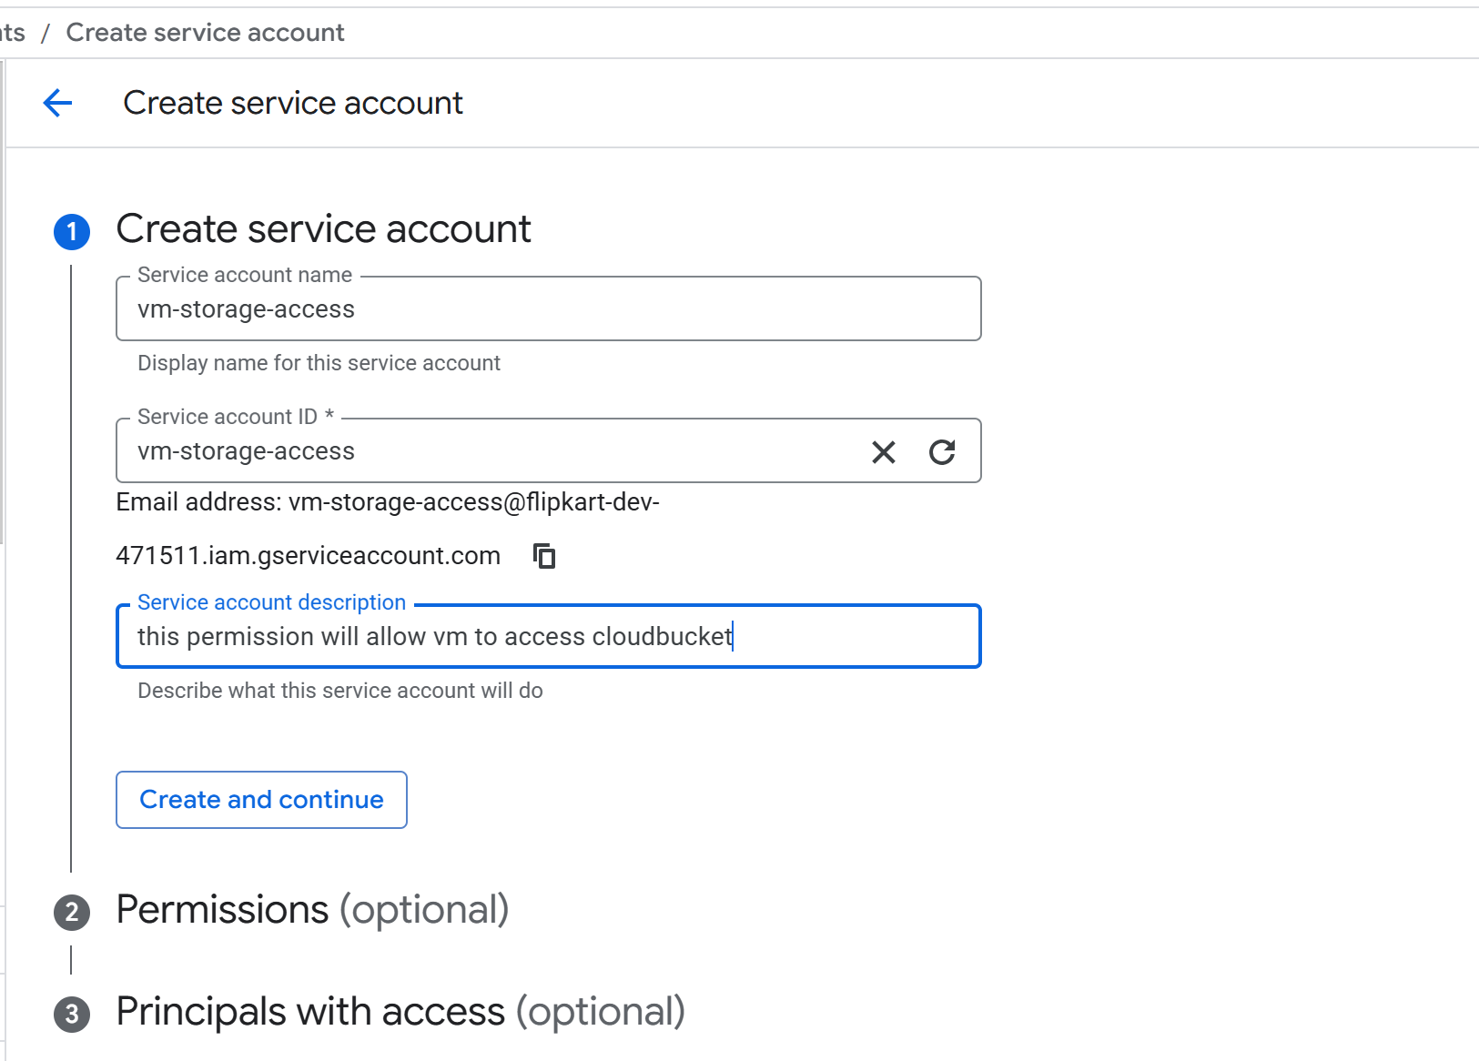



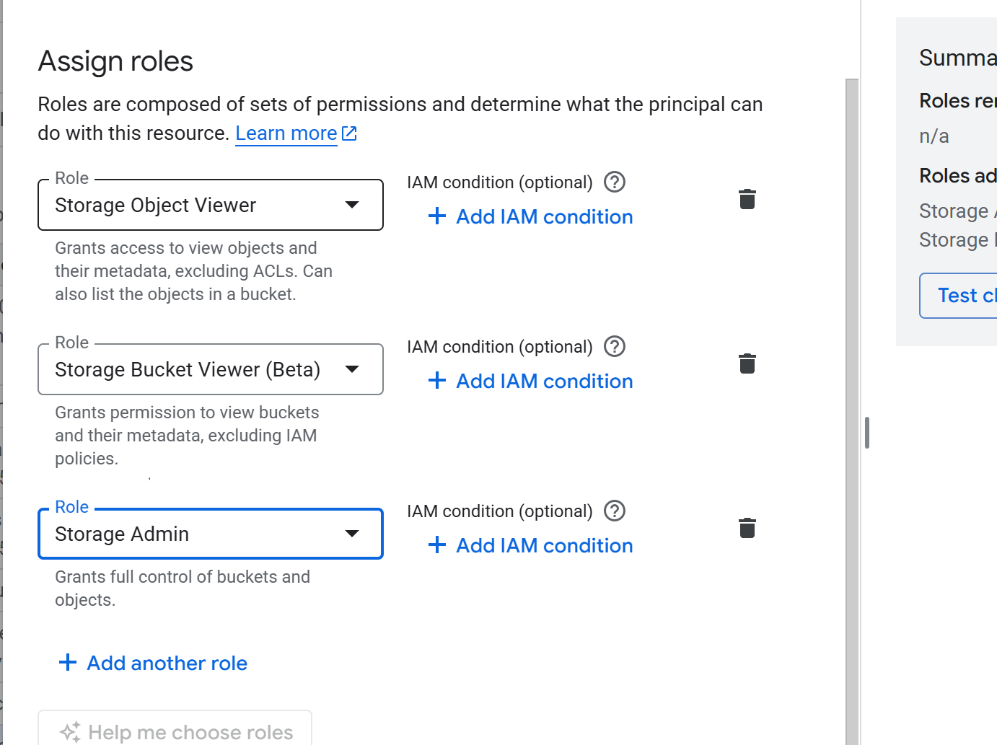

Click on DONE

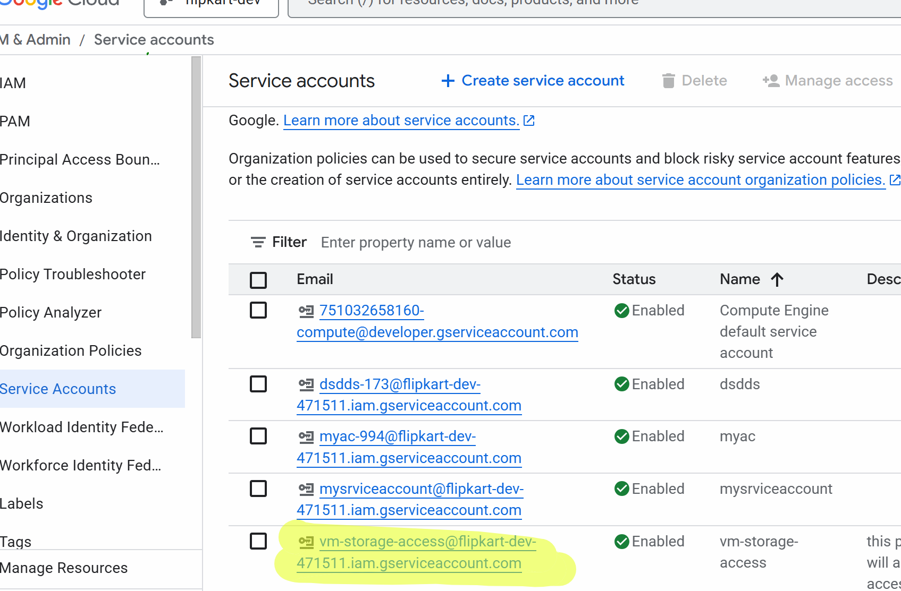



Now we will create a VM

Go to compute engine-> launch a VM

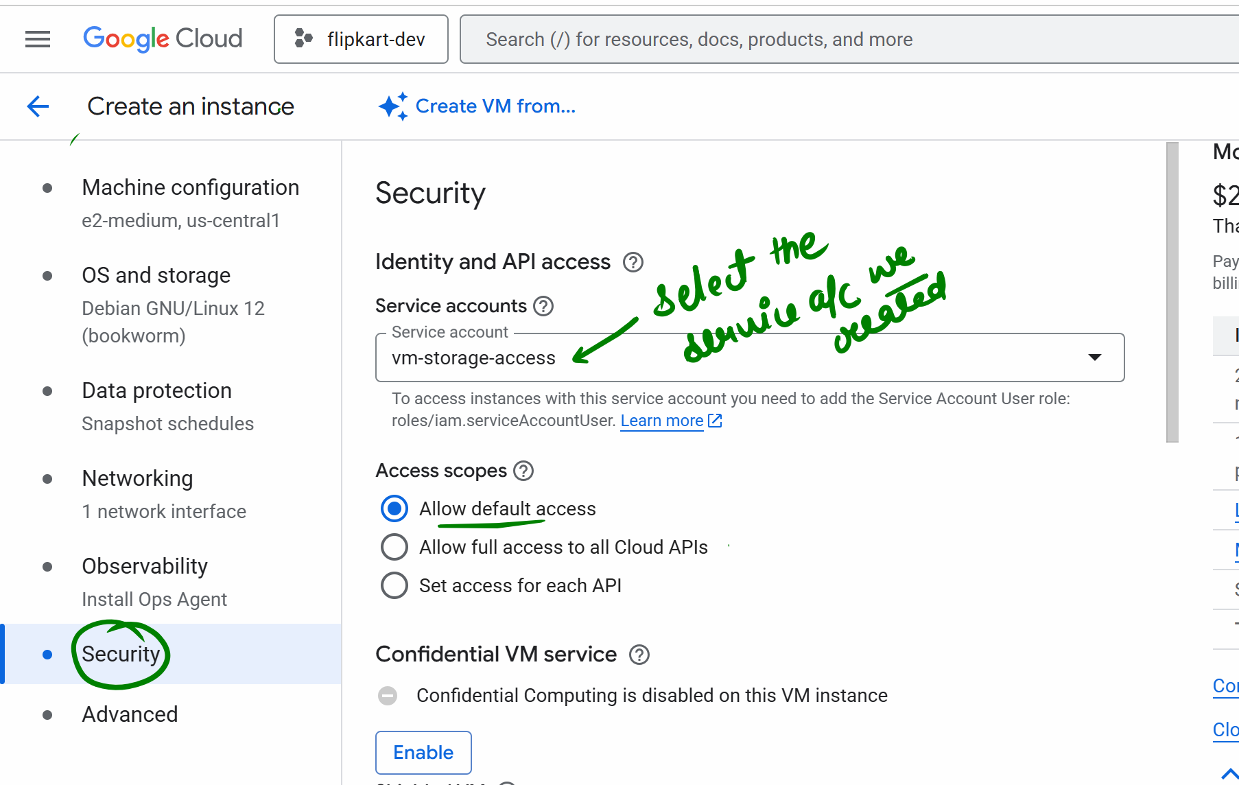



If you select the default access , GCP assigns a limited set of scopes to VM service account. These scopes decide which api the VM can call , even if the service account has right iam roles  
Lets say later on when u try to copy a file from vm to storage and u get error like 403 provider scope(s) not authorized it is because u have selected allow default access



Ssh to the machine

# sudo su

# sudo apt update

# sudo apt install google-cloud-sdk -y

####### LIST BUCKETS ######

# gsutil ls  
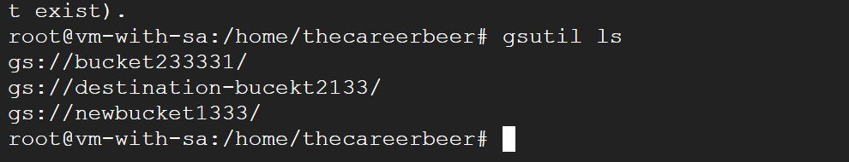

# list the files in the bucket

# gsutil ls gs://bucket name

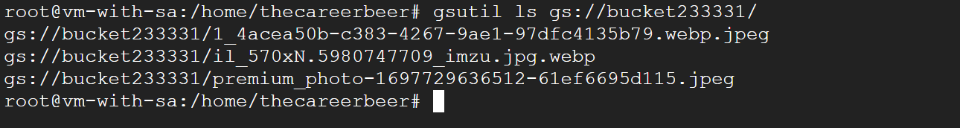

## WE CREATE A FILE AND COPY IN THE CLOUD BUCKET

# echo "hello from vm" > test.txt

gsutil cp test.txt gs://bucket233331/ # here gs://bucket233331/ is the bucket name

